**Terrence PERSONA TEMPLATE**

|  |  |  |  |  |  |
| --- | --- | --- | --- | --- | --- |
|  | **PERSONA PHOTO** |  | **GOALS AND MOTIVATIONS** |  | **CHALLENGES AND OBSTACLES** |
| * **Financial Stability & Retirement** – Wants to secure his financial future and ensure a smooth transition into retirement within the next decade. * Knowledge **Sharing & Mentorship** – Passionate about training the next generation of actuaries and ensuring the profession remains highly respected in South Africa. | * Alcohol consumption * Has been emotionally weak since the passing of his wife * Finds it difficult to ask for help * **Reluctant to Change** – Struggles to adapt to new tech trends, such as AI-driven risk modelling, preferring traditional actuarial methods. * **Work-Life Balance** – Often overcommits to work, leaving little time for family and personal interests. |
|  |  |
| **QUOTATION** | |
| **"Birds of the same feather flock together"** | |
| **NAME** | |
| Joshua Mahlaba | |
| **AGE** | |  |  |
| 53 | | **FRUSTRATIONS** | **SOURCES OF INFORMATION** |
| **GENDER** | | * Gets frustrated when his team loses a game * He feels like he sometimes does not do a good job as a single father * People who intrude with his personal life | **BOOKS** |
| Male | | **Predictive modeling applications in actuarial sciences** |
| **LOCATION** | | **BLOGS** |
| Johannesburg, South Africa | | **Actuarial eye** |
| **OCCUPATION** | | **CONFERENCES** |
| Business Finance | | **Work conference calls with his team at work** |
| **JOB TITLE** | | **EXPERTS** |
| Actuary | | **N/A** |
| **HIGHEST LEVEL OF EDUCATION** | | **MAGAZINES** |
| Masters Degree in Finance | | **The wall street Journal** |
| **ANNUAL INCOME** | | **WEBSITES** |
| $ 120,988 | |  |  | **Actuaries digital** |

# ChatGPT Prompts.

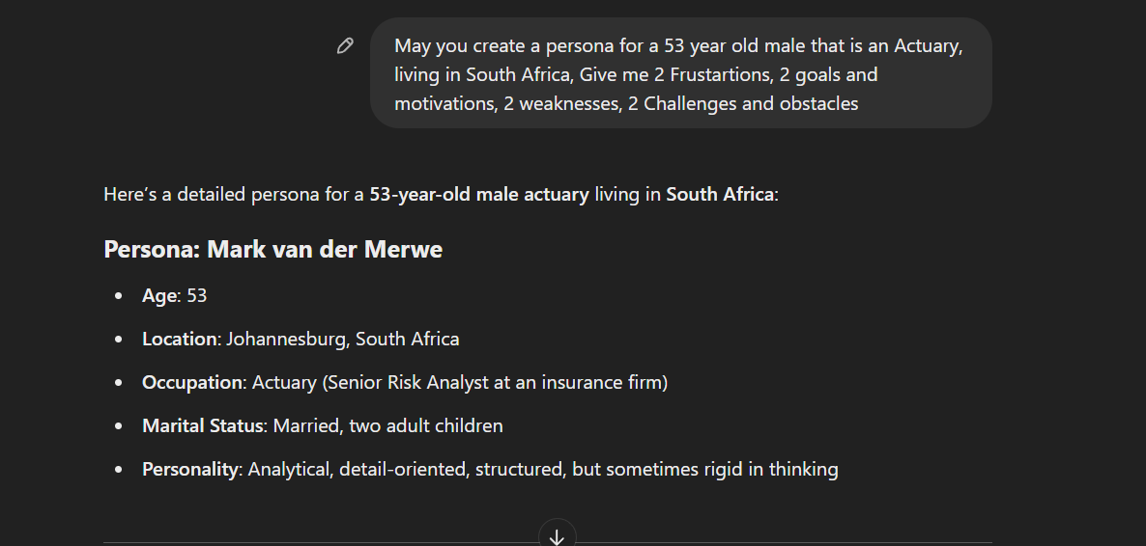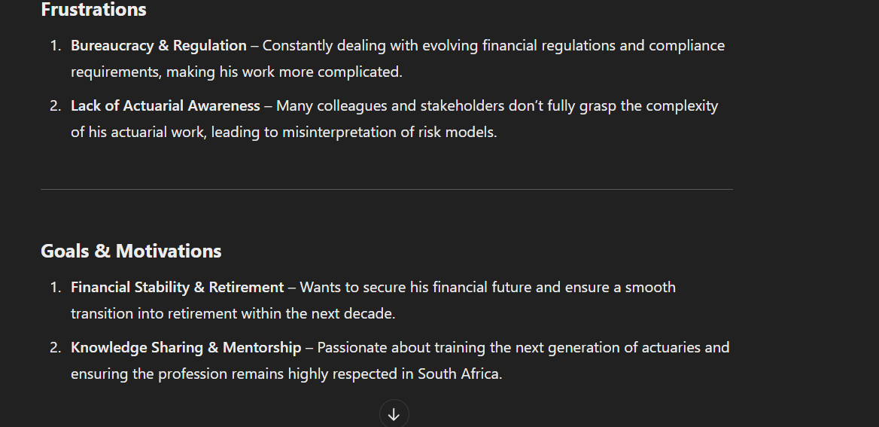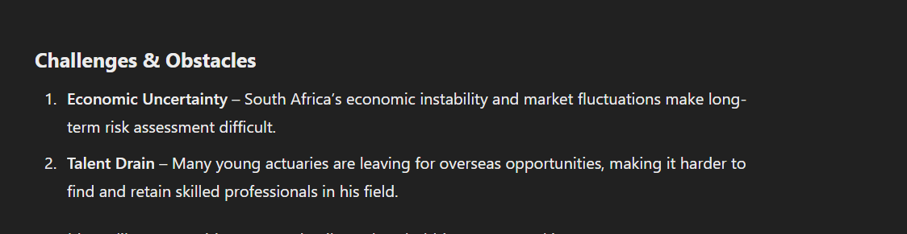

I made some changes on some of the prompts giving

# Testing

(*NAISH*)

### **Initial Impressions**

Milton Jones is a well-rounded character who exactly embodies the spirit of a seasoned actuarial practitioner. His financial focus, guidance zeal, and struggle with personal concerns make him a believable character. His reluctance to embrace AI-driven risk modeling creates a fascinating professional challenge, making him credible in the context of modern actuarial practice.

### **Strengths**

Realism – Joshua's vocational experience, pitfalls, and interests make him come across as an actual person.

Depth in Professional Challenges – His reservation against applying AI actuarial methods is a genuine issue facing experienced professionals upon adopting new technology.

Emotional Complexity – His emotional lament about his deceased wife and concern at juggling work and personal life make him more relatable.

Clear Professional Goals – His goals for financial independence and mentoring are well-defined.

### **Areas of Improvement**

More Personal Interests – The character is work-focused. Adding leisure activities or hobbies (e.g., favorite hobbies, sports, music, or spending time with his son) would complete him.

Building Work-Life Conflict – It's mentioned that he over-commits at work, but how does it affect relationships? Does he feel guilty, burnout, or strained family relationships?

Social Trends – Is Joshua introverted or extroverted? How does he interact with co-workers, protégés, and his family?

### **Overall Assessment**

Joshua Mahlaba is a down-to-earth and interesting character with deep professional and personal layers. Incorporating more information about his recreational activities, home life, and interpersonal relationships might make him even more relatable and fascinating.